Smart Home Sensor
Project Proposal

Team EcoNest
Sutton Elliott
Shiv Ranchhod
William Xu
Evan Johnston
Tyler Rottermond
Sriharsha Jandhyala

Department of Computer Science
Texas A&M University

2/13/2026

Table of Contents

1 Executive summary 3
2 Introduction 4
2.1 Needs statement 4
2.2 Goal and objectives 4
2.3 Design constraints and feasibility 5
3 Literature and technical survey 6
4 Proposed work 9
4.1 Evaluation of alternative solutions 9
4.2 Design specifications 11
4.3 Approach for design validation 15
5 Engineering standards 17
5.1 Project management 17
5.2 Schedule of tasks, Pert and Gantt charts 19
5.3 Economic analysis 21
5.4 Societal, safety and environmental analysis 21
5.5 Itemized budget 23
6 References 23
7 Appendices 25
7.1 Product datasheets 25
7.2 Bios and CVs 30
1 Executive summary
Smart home technologies have become increasingly common, yet most existing systems rely on isolated devices and static, rule-based automation that fails to adapt to occupant behavior or provide meaningful insight. Despite widespread adoption of smart security products, residential burglaries continue to occur at high rates, and homes without effective monitoring remain significantly more vulnerable. Similarly, while smart energy devices promise efficiency gains, inactive and poorly coordinated smart home equipment wastes billions of dollars in electricity annually. These shortcomings reveal a critical gap: current smart homes collect data, but do not reason over it intelligently.
The goal of this project is to design and prototype an AI-driven centralized smart home system that uses machine learning to analyze security and energy data holistically, enabling intelligent automation, anomaly detection, and personalized decision support. Rather than relying on predefined thresholds or simple if–then rules, the proposed system learns normal household behavior over time and uses that knowledge to optimize energy consumption and enhance home security with minimal user intervention.
The system architecture is built around a Raspberry Pi based edge hub that aggregates data from multiple sensors, including smart energy plugs, motion sensors, and sound sensors distributed throughout a residence. These sensors continuously generate multi-modal data streams describing appliance usage, occupancy patterns, and environmental activity. Raw data is preprocessed locally and stored in a structured SQL database, ensuring low-latency access and improved privacy while supporting scalable machine learning workflows.
Artificial intelligence is the core differentiator of the system. Machine learning models analyze historical and real-time sensor data to identify trends, detect abnormal behavior, and generate actionable insights. Time-series forecasting models learn typical energy and activity patterns for each household, enabling predictions of future usage and automated adjustments to reduce waste. Anomaly detection algorithms flag unusual events such as unexpected appliance power draw, abnormal sound levels, or motion during unoccupied periods, allowing the system to proactively alert occupants or trigger automated responses. These AI-driven insights are continuously refined as new data is collected, allowing the system to adapt to changing household routines.
Users interact with the system through a web-based dashboard that presents AI-generated insights rather than raw sensor readings. The interface highlights detected anomalies, predicted trends, and personalized recommendations, while real-time push notifications ensure occupants are immediately informed of potential security risks or inefficiencies. Automation capabilities allow the system to act on AI decisions, such as adjusting device states or notifying users when human intervention is required.
The expected result of this project is a fully integrated prototype that demonstrates the feasibility and value of machine learning based reasoning in smart home environments under realistic cost and deployment constraints. By transforming raw sensor data into contextual understanding and intelligent action, the system advances smart home technology from reactive monitoring to adaptive, AI-driven decision making, offering meaningful improvements in security, energy efficiency, and user awareness.

2 Introduction

2.1 Needs statement
Over 94 million US households use smart security tools (Safehome, 2025), yet according to the FBI (Federal Bureau of Investigation), break-ins still occur every 26 seconds (FBI.gov, 2019). Additionally, the latest FBI Uniform Crime Reporting Statistics says that homes without security systems are 3 times more likely to be burglarized, (Alarms.org, 2019). From an energy perspective, smart thermostats claim to reduce costs from 10-15% per year (Globalnewswire.com, 2021). However, inactive smart home devices waste about 19 billion dollars annually (nrdc.org, 2015). Therefore, a system that consolidates smart devices is needed to help homeowners better understand and respond to security risks and inefficient energy use across their smart devices.

2.2 Goal and objectives
Under normal conditions, it is up to homeowners to operate their home in a way that conserves energy and provides security to its occupants. The problem is that even if they want to conserve energy or be secure, people might not know how, or forget, or maybe are just too lazy to operate their home in a way that does conserve energy and ensures security. Through reasoning, homeowners can have their home automatically operate in a way that conserves energy and enhances security.
Thus, the main goal of this project is to use reasoning on a centralized smart home system to optimize energy consumption and enhance security.
In order to use reasoning, we have the following objectives:
- The smart home system should be able to collect different types of data for the machine learning models to train and make predictions with.
  - By having many different types of data, the models will be better trained to accomplish our goal.
- The smart home system should quickly and securely transfer collected data.
  - As we are working with continuous and sensitive data, we need to be able to effectively transfer that to the models.
Once accomplished our objectives pertaining to reasoning are:
- The system should be able to detect anomalies in the collected data.
  - This can be used to enhance the security of the occupants. They can detect power issues in appliances and possible break-ins and respond properly to ensure our goal is met.
- The system should be able to analyze trends in the collected data.
  - This will be used to make predictions on how the occupants will operate the home, and automatically respond based on these trends.
- The system should be able to provide recommendations to the occupants.
  - Using various data sources, the system should be able to provide recommendations to the occupants pertaining to energy conservation and security of their home.
Other objectives:
- The system should allow occupants to access collected data and be informed of any changes.
  - While we want the home to automatically run considering energy consumption and security, the occupants should know about these changes in case of wrong predictions allowing the occupants to change the responses.

2.3 Design constraints and feasibility
Technical Constraints:
The security portion of our system relies on motion and sound sensors, while the energy-monitoring devices and smart plugs will provide the data for each of these focuses on our design. This data will be provided to do a machine learning based analysis of the security and energy consumption. These sensors must reliably capture activity patterns and events that take place within their respective environments that can be processed and stored in a structured database. Machine learning techniques are then required to analyze this data, identify abnormalities, and generate meaningful alerts and recommendations. This all will be managed and viewable through a web or mobile application. The technical design must ensure that the sensor data is accurate and consistent to support the AI system, so that the reasoning behind it will be accurate and reliable.
Physical Constraints:
Motion and sound sensors will need to be physically deployable within residential areas and positioned to effectively capture room activity and not be intrusive after installation. Proper sensor placement is essential to ensure that the data collected reflects the actual data based upon the energy consumption and security-related events. Poor placement of these sensors will negatively impact the machine learning model and in turn the learning accuracy. Energy-monitoring devices also need to be placed at appropriate power outlets to provide reliable usage and energy consumption data. All hardware must be compatible with the overall system and non-invasive of the homeowners space. These physical constraints directly affect the data quality and reliability of the analysis of the machine learning model.
Economic Constraints:
The total project budget is configured to be $300, or approximately $50 per person (6 group members), with a target cost for each unit being less than 150 dollars. This constrains the selection of the different components, namely sensors and computing hardware, favoring low-cost components. In addition to this, we would need to favor lower-cost, commercially available motion, sound, and energy-monitoring devices. As a result, the AI/ML approach needs to be lightweight models and efficient data processing techniques rather than computationally expensive methods. While cost is a constraint, the primary objective remains the idea of demonstrating the feasibility of AI-driven security and energy analysis within the budget requirements that are put before us.
Temporal Constraints:
The project timelines is 10 to 11 weeks, which requires us to integrate the motion, sound, and energy sensors to allow sufficient data collection to properly train our machine learning model. Hardware building and deployment must be completed within the first phase of the project which is about the first 4 weeks of the project. This will be around the time of the first Critical Design Review to enable us to gather data, train the model, and validate the design. The feasibility of the project depends on alignment of the sensors and dataset, in addition to the model complexity within the available development time.

3 Literature and technical survey
Ring Alarm Pro Security Kit:
The Ring Alarm Pro Security Kit is a smart home security system designed to detect intruders through different entry ways, including doors and windows. The system has a combination of door/window contact sensors, motion detectors, and a centralized base station. The system integrates closely with a Ring doorbell system and provides real-time updates and alerts to users through their mobile devices. Installation is designed to be simple and accessible for technologically illiterate users, which makes it widely used for home security systems.
Pros:
- Well-integrated security system that includes cameras, alarms, and mobile notifications
- Easily installable and clear setup that requires little technical expertise
- Reliable motion sensing for intrusion detection
- Scalability within the system with support for additional sensors and devices
Cons:
- Focused almost exclusively on security
- No energy monitoring, tracking, or analysis
- Limited cross-device intelligence beyond rule-based alerts
- No machine learning used within the system for behavioral or pattern recognition
NTI E-1W Environment Monitoring System
The NTI E-1W Environment Monitoring System is an environmental monitoring system that is intended for larger facilities and rooms such as server rooms or industrial spaces. This system supports a wide range of sensors that track and analyze temperature, humidity, liquid detection, smoke, and power status, and trigger alerts when predefined thresholds are not met. Data from the system is then moved over a network interface and can be accessed remotely though web-based dashboards or integrated into other monitoring systems.
Pros:
- Supports a wide variety of sensors throughout the environment
- Threshold-based monitoring with alerts for hazardous conditions
- Designed for long-term use
- Connect via network with remote access and alerts available
Cons:
- Relies on threshold based rules that are static and predefined
- No threat or intruder detection
- No reliable way to integrate other consumer smart devices
- Lacks predictive analysis or insights
Ecobee SmartSensor:
The Ecobee SmartSensor is a wireless sensor designed to extend the range and functionality of Ecobee smart thermostats by detecting temperature and the amount of people in a room. These sensors enable HVAC systems to adjust to heating and cooling based on the amount of people within a room instead of a single thermostat. The SmartSensor communicates with the thermostat and is battery powered, allowing flexible placement within the home.
Pros:
- Room occupancy and temperature sensing
- Improves the HVAC efficiency and comfort within the home
- Simple installation and communication
- Displays use of occupancy-based automation
Cons:
- Limited to temperature and motion sensing
- Requires to already be using Ecobee thermostat
- No security or intruder detection
- No centralized analytics beyond energy efficiency
Philips Hue Smart Lighting System:
The Philips Hue Smart Lighting System is a consumer smart lighting platform that provides lightbulbs, motion sensors, and centralized control through a mobile application. The system enables users to automate lights based on a schedule, occupancy detection and predefined rules. The product communicates wirelessly through a centralized hub and works well with other devices such as a Google Home or Alexa.
Pros:
- Automation based on occupancy and scheduling for specific devices
- Reliable consumer smart home system
- Displays energy-saving potential through lighting control
- Compatibility with common third-party devices
Cons:
- Focused on lighting devices
- Mainly used for sensing motion and ambient light within the environment
- Automation is rule-based and not based on trends or reasoning
Aqara Smart Home Hub with Multi-Sensor Suite:
The Aqara Smart Home Hub with Multi-Sensor Suite is a consumer IoT platform that is designed to integrate wireless sensors including but not limited to motion detectors, door and window sensors, temperature and humidity sensors, and presence sensors. These sensors communicate with a centralized hub that processes and analyzes data. Based on this data, it allows users to create automations and receive alerts through a mobile application.
Pros:
- Supports a wide range of sensors (environmental, security, etc.)
- Low-cost and scalability
- Displays multi-sensor usability within a single ecosystem
Cons:
- Limited analytics beyond simple automations and alerts
- Heavily system dependent
- No machine learning for trend analysis and predictive insights
- Data integration across energy, security, and environment is shallow
Proposed Design:
The proposed Smart Monitoring System differs from the existing smart home products that are on the market by prioritizing artificial intelligence and machine learning as the core selling point of this system. This is different from the isolated devices or monitoring that only takes in data for one specific niche or category. Sensor data related to security events and energy usages will be collected and presented on a web or mobile application, where all the data will be viewable for the user. In addition, the system will also use machine learning techniques to analyze the data to identify patterns, detect abnormalities, and generate meaningful alerts and recommendations. Unlike the current systems on the market that are primarily rule-based or threshold-based, instead the proposed design will use the data to drive reasoning to provide insight across both home and security and energy efficiency. By focusing on intelligent analysis of past and present data, the system enables users to make informed decisions and understand based on the full context instead of simply raw sensor data.

4 Proposed work

4.1 Evaluation of alternative solutions

Preexisting Smart Home Device (Google Nest)
Pros:
- Professional user interface
- Reliable hardware
- Minimal design time (more time for ML)
- App supports
Cons:
- Closed source system (!)
- Data stored by Google instead of locally
- Subscription based system

Microcontroller Based System (ESP32)
Pros:
- Low cost and power consumption
- Native wireless communication support (WiFi/ Bluetooth)
Cons:
- Limited processing power (video streaming/ image processing)
- Limited storage
- Difficult to scale

Cloud Based Solution (devices send all information to cloud)
Pros:
- Scalability
- Easy ML implementation
- Access from anywhere extremely easily over internet
Cons:
- High dependence on internet
- Increased latency for quick actions
- Cloud hosting costs (subscription fees)
- Privacy and security concerns

Separate Energy and Security System
Pros:
- Simpler design for each
- Can optimize independently
- Reduced cost per system
Cons:
- Duplicate hardware might drive costs above savings
- No shared data
- No integrated insights (relating camera to power usage)

Dedicated NVR with Separate Energy Monitor
Pros:
- NVR is built for security, so minimal design effort spent there
- Reliable and efficient video streaming
- Reduces load on energy monitoring system
Cons:
- Significantly higher costs
- Limited integration between two systems
- Less flexibility (NVR is not open source)
- No integrated insights (relating camera to power usage)

Raspberry Pi Smart Home (Proposed Solution)
Pros:
- Computing power sufficient for data streaming and analysis
- Linux based platform allows for open sourced software
- Easy integration of several sensors
- Storing data locally eases privacy and latency concerns
Cons:
- High relative power consumption
- Complex system design
- Security risk if done poorly

Overall, we are choosing to move forward with the option of the Raspberry Pi due to its extreme flexibility for what we consider to be a very fair price. We can implement some machine learning trends in it without breaking the bank, while also having the energy system incorporated into the Pi allowing for one system. Some alternatives include having two systems (see NVR), but this would mean having double the setup for an end user, which is not desirable. So while the other systems can offer better security for a higher cost, we are choosing to run off a Pi for its low cost and scalability.

4.2 Design Specifications
This section presents the detailed design of the Smart Room Monitor, a centralized smart home monitoring system focused on applying reasoning for security and energy management. The design is organized into 6 modules that collectively enable sensor data collection, cloud storage, analysis, and an user dashboard. Figure 1 below provides a high-level block diagram of the full system architecture, and the subsections after this section describing each module in detail.

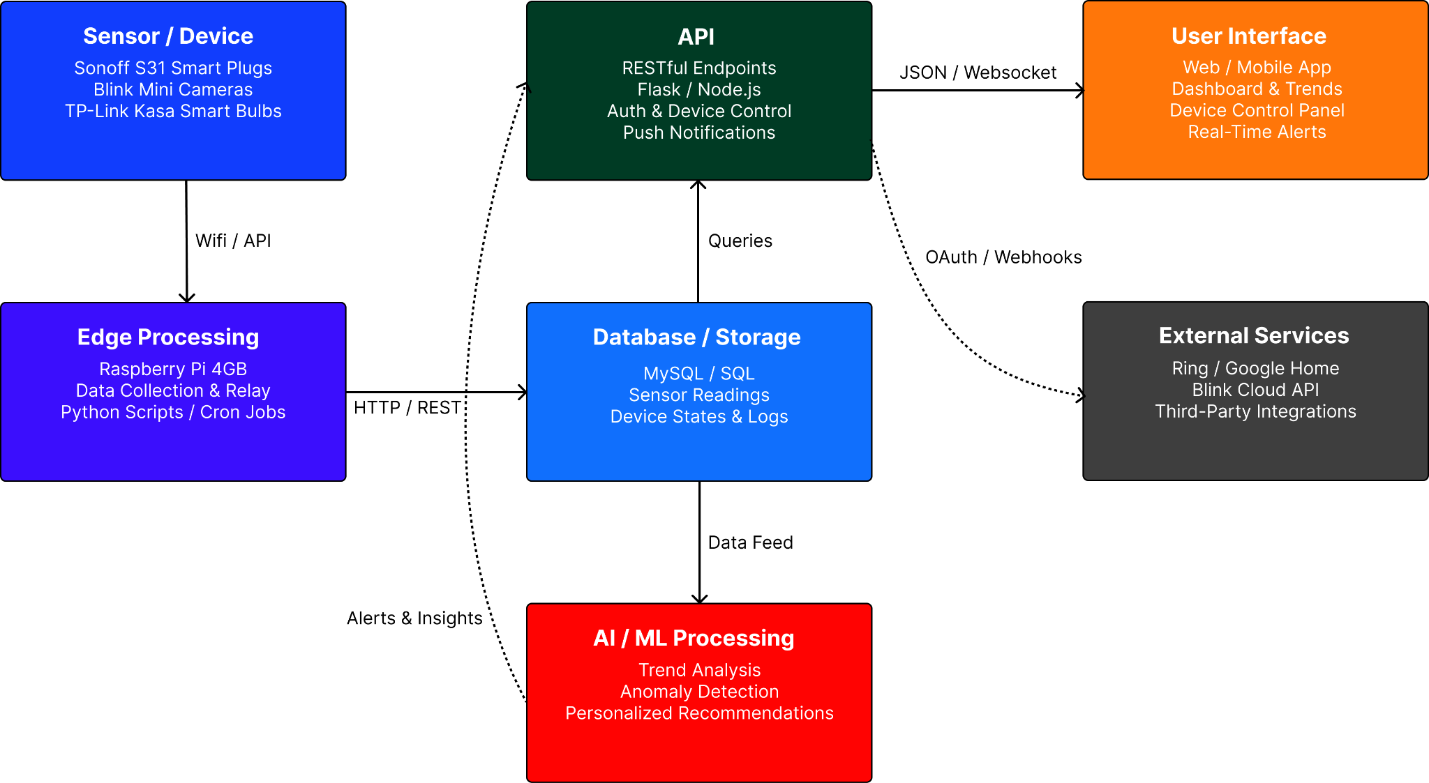

Figure 1: High-level system architecture of the Smart Room Monitor. Six modules communicate via Wi-Fi and REST APIs to collect sensor data, process it with ML, and present insights to the user.

4.2.1 Sensor / Device Layer
The Sensor/Device Layer is the physical hardware deployed throughout the home. Each per-house unit consists of a Raspberry Pi 4 Model B acting as the central hub, connected to two Sonoff S31 smart plugs, a sound sensor, and a motion sensor. The system will be deployed across 3 houses for testing and validation. Figure 2 below illustrates the hub and spoke architecture of a single unit.
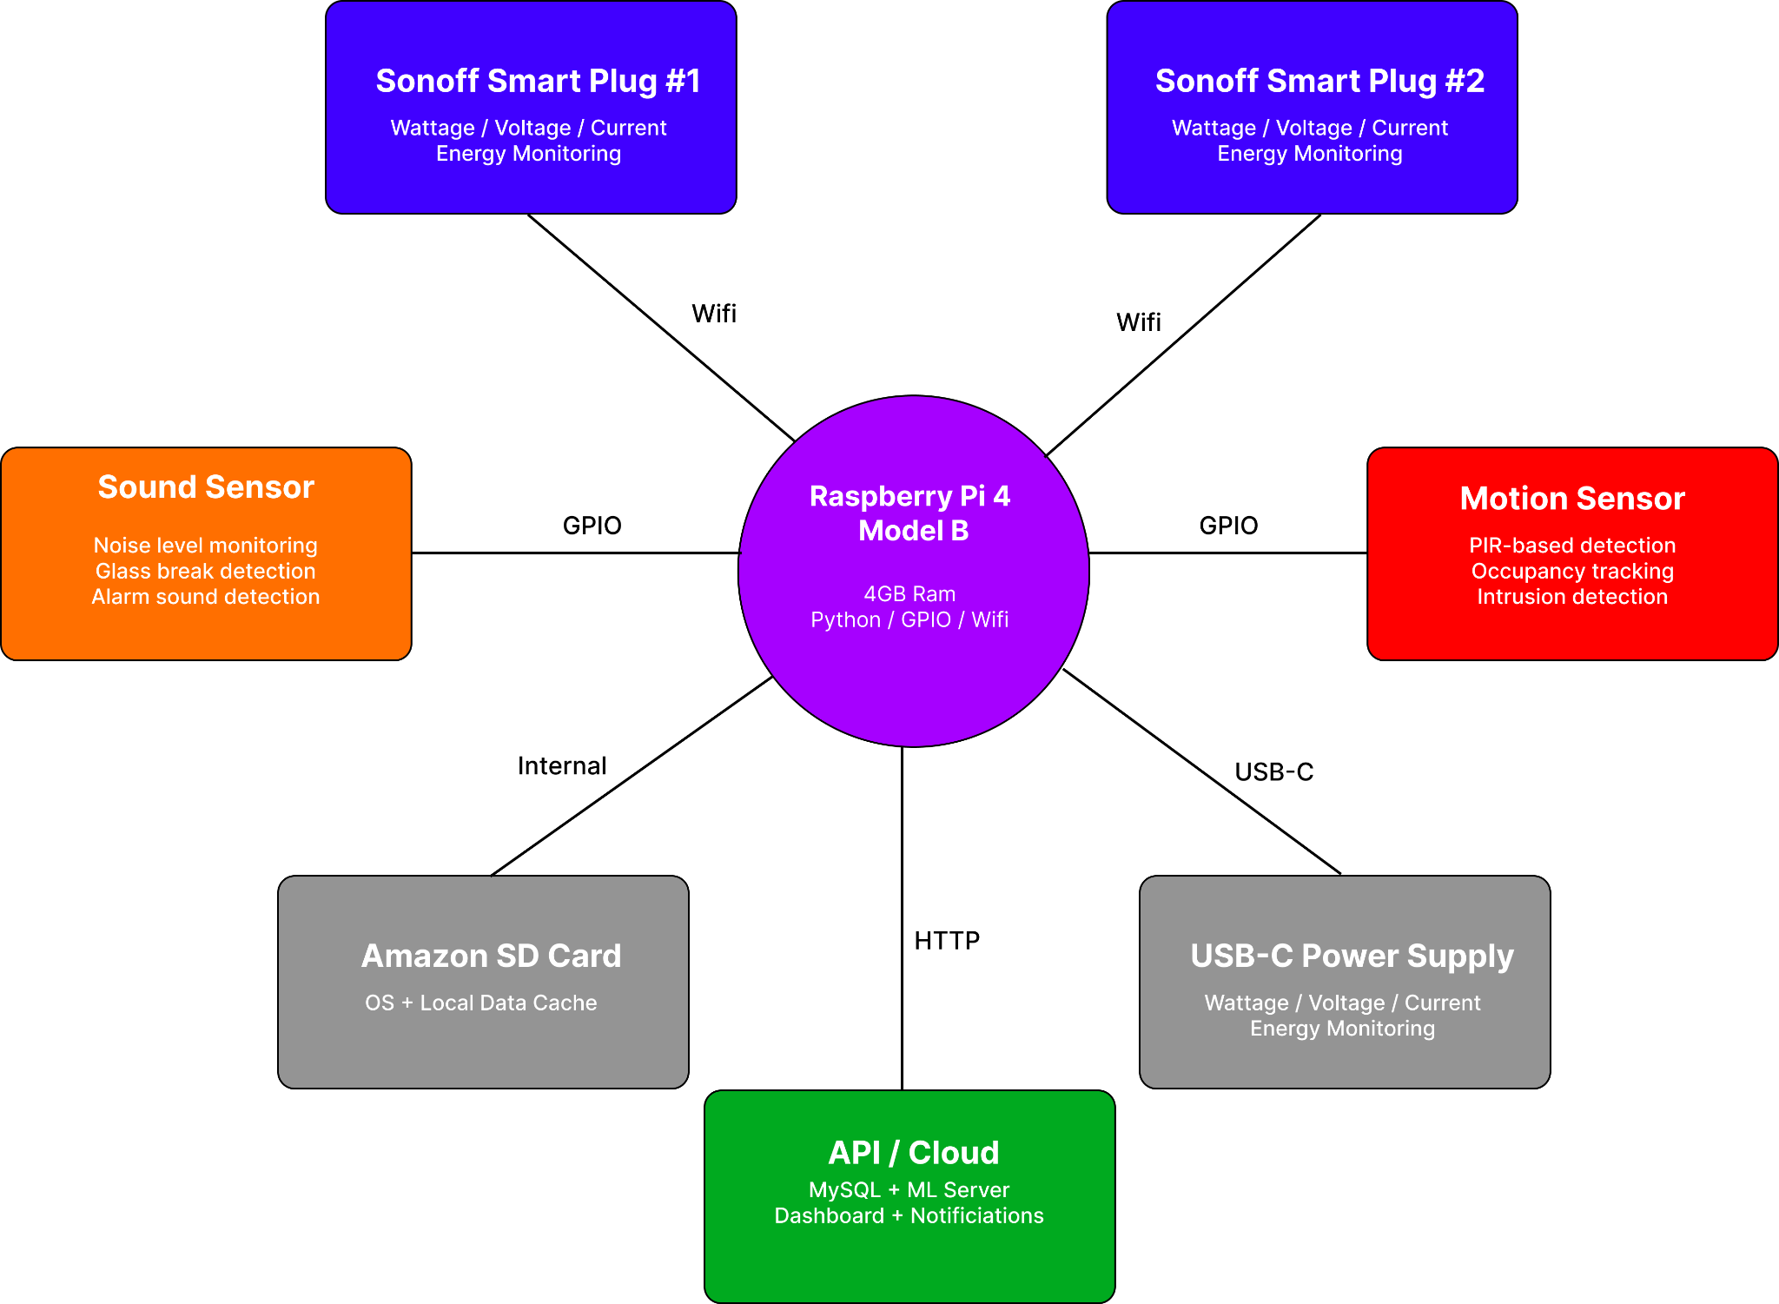
Figure 2: Hub and spoke architecture of a single per-house sensor unit. The Raspberry Pi 4 serves as the central hub, communicating with Sonoff S31 smart plugs over Wi-Fi and reading motion and sound sensors via GPIO pins. Data is forwarded to the API/cloud layer over HTTP.

The Sonoff S31 plugs provide real-time wattage, voltage, and current readings for each connected appliance via their local Wi-Fi API, covering the energy monitoring use case. The motion sensor detects movement within a room to identify unauthorized entry or occupancy patterns, while the sound sensor monitors for abnormal noise levels that may indicate a security concern such as glass breaking or an alarm going off. The motion and sound sensors connect directly to the Raspberry Pi via GPIO pins, while the smart plugs communicate wirelessly over the home Wi-Fi network. This layer was designed to use commercially available, off-the-shelf components to keep costs within the $300 budget while covering the two primary use cases of security and energy management.

4.2.2 Edge Processing (Raspberry Pi)
A Raspberry Pi 4 Model B with 4 GB of RAM is used as the local edge-processing hub for each house. Running Raspberry Pi OS, it executes Python scripts to continuously read data from the connected sensors. For the Sonoff smart plugs, the Pi uses the Sonoff LAN library to query energy data over the local network without relying on external cloud services. The sound and motion sensors are wired to the Pi's GPIO pins and read directly through Python libraries. The Pi preprocesses raw readings, such as converting raw wattage samples into rolling averages and filtering noise from the sound sensor, then forwards the cleaned data to the API layer via HTTP POST requests. This local preprocessing reduces unnecessary network traffic and provides a layer of resilience if the internet connection is temporarily lost, as readings can be cached locally on the Pi and synced when connected.

4.2.3 Database Layer
All sensor data is persisted in a MySQL relational database hosted on the same local network or on a cloud instance. The schema is organized around three core tables. The first, device_readings, stores timestamped energy metrics including watts, voltage, amperage, and cumulative kilowatt-hours for each smart plug. The second, sensor_events, logs timestamped motion detections and sound level readings with fields for event type, severity, and room location. The third, device_states, tracks the current on/off status and last-changed timestamp for every device. Foreign keys link readings to a devices table that stores metadata such as device name, room assignment, and type. Indexing on timestamp and device_id columns ensures that trend queries and anomaly detection can scan recent data efficiently. The database also stores user preferences and notification history so the AI module can personalize its recommendations over time.

4.2.4 API Layer
The API layer is implemented as a RESTful web service using Flask with Python. It creates endpoints for ingesting sensor data from the Raspberry Pi, querying historical readings for the dashboard, issuing device control commands, and registering push-notification tokens. Authentication is handled via JSON Web Tokens to ensure that only authorized users and devices can interact with the system. For real-time updates, the server maintains a WebSocket connection with the frontend, pushing new readings and alerts the moment they arrive rather than requiring the client to poll. The API is designed to be extensible so that third-party integrations such as Ring or Google Home could be added in future iterations via OAuth 2.0 flows.

4.2.5 AI / ML Processing Module
The AI/ML module is the core differentiator of the Smart Room Monitor and will be hosted on a dedicated laptop. It pulls data from the MySQL database at fixed intervals, including energy readings from device readings and motion and sound logs from sensor events. Raw sensor data is first passed through a feature engineering pipeline that generates meaningful inputs for the models, including time-of-day and day-of-week encoding, rolling power averages over 5-minute and 30-minute windows, motion frequency per hour, and sound level variance. These features feed into four key ML capabilities.
For trend analysis, the module uses time-series forecasting models from Hugging Face to learn each household's typical energy and activity patterns and predict future usage. For anomaly detection, an isolation forest model identifies outliers in energy consumption and unusual motion or sound events that deviate from the learned baseline, such as a forgotten appliance drawing power overnight or unexpected motion during vacant hours. For personalized recommendations, the system uses the detected patterns to generate actionable suggestions tailored to each household, such as shifting high-energy appliance usage to off-peak hours or adjusting device schedules based on observed routines. For real-time adjustments, the module continuously evaluates incoming data against the trained models and can trigger immediate automated responses through the API layer, such as sending an alert when a motion and sound anomaly coincide, suggesting a potential security event.
Models are retrained weekly using the latest accumulated data to adapt to changing household behavior. Hugging Face Transformers and scikit-learn serve as the primary ML frameworks, with model artifacts versioned and stored locally. Anomalies, predictions, and recommendations are written back to the database with timestamps, device IDs, confidence scores, severity levels, and suggested actions, which the API layer then serves to the frontend and notification system.

4.2.6 User Interface
The user interface is a web app built with React and served through the API layer. The dashboard home screen displays an overview with real-time energy consumption gauges, motion and sound alert indicators, and device on/off toggles. A trends page renders historical charts, allowing users to visualize energy usage over days, weeks, or months and compare rooms side by side. The alerts page aggregates all notifications chronologically and lets users acknowledge or snooze them. Push notifications are delivered via Firebase Cloud Messaging to both web and mobile browsers, ensuring users receive critical alerts even when the app is closed. The interface follows a card-based layout, presenting data as a carousel of digestible information cards rather than dense tables. The design will be prototyped in Figma before development.

4.2.7 Data Flow
Figure 3 shows the data flow for a single sensor reading, from the moment a smart plug captures a wattage value to the point where the user receives an alert. This pipeline executes in near real time, with typical latency under five seconds from measurement to notification.

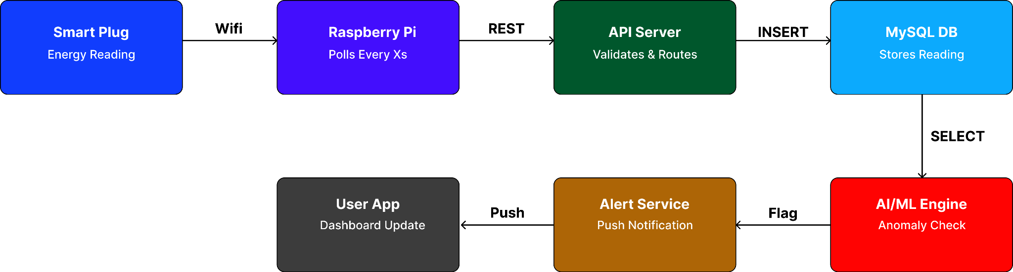
Figure 3: End-to-end data flow for sensor reading. A smart plug transmits energy data to the Raspberry Pi over Wi-Fi, which forwards it through the REST API to the MySQL database. The ML engine queries the database, flags anomalies, and triggers push notifications or automated device responses.

4.3 Approach for design validation

This section will outline how we will verify that our smart home system effectively meets the stated goals of optimizing energy consumption and enhancing home security for homeowners. The validation process will evaluate whether the system successfully collects sensor data, transfers it securely, analyzes it using reasoning techniques, and provides useful recommendations and alerts to homeowners. For thorough evaluation, hardware system components will be individually tested, followed by software validation and reasoning functionality tests, and end-to-end system performance under practical, realistic conditions.

4.3.1 Hardware Component Testing
Each hardware component of the system will be individually tested to verify proper functionality in the context of overall system performance.
- Sonoff Smart Plugs: Test accuracy of voltage, current, and power readings under different appliance loads
- Sound Sensor: Simulate normal and abnormal sound events to evaluate detection reliability
- Motion Sensor: Test home intruder detection under various movement conditions
- Raspberry Pi 4 Model B: Verify data collection/polling, local processing, and effective communication with the API server
- USB-C Power Supply: Evaluate stability of power delivery to the Raspberry Pi during continuous operation
- Amazon SD Card: Test data caching during Wi-Fi network outages and successful synchronization afterward

4.3.1 Software and Reasoning Testing
The software and machine learning portion of the system will be validated by testing data transfer, model reasoning outputs, and generation of alerts/recommendations in the context of energy optimization and security.
- Data Processing: Verify sensor data is received, formatted and transmitted through the API without data corruption
- Database Reliability: Confirm data is stored accurately in the database, sensor and device states are logged, and queries return information correctly
- AI Anomaly Detection: Introduce scenarios that trigger alerts/recommendations (e.g. energy spikes, unexpected motion, loud noise) and verify that the ML system flags and responds to those events correctly
- AI Trend Analysis: Collect data on hourly and multi-day intervals and validate the system identifies patterns in intrusion detection and energy consumption
- AI Reasoning: Confirm the AI system generates actionable suggestions for reducing energy consumption and improving security based on trend analysis/anomalies and verify text output
- Alerts and Notifications: Verify any alerts or push notifications generated are transmitted through the API and delivered to the user app in real time
- User Dashboard and App: Perform unit tests on key user interface features in the app and ensure insights, sensor/device data, and alerts are clearly displayed for interpretation

4.3.3 End-to-End Testing
End-to-end validation confirms that the system operates correctly under realistic home conditions. It verifies the practicality of the system for homeowners and if it is viable for achieving the key objectives of improving the energy efficiency and security of a given household.
- Full Pipeline Verification: Trigger multiple events at the sensor level and test simultaneous events (i.e. motion and sound sensor detect abnormalities) and confirm data flows correctly through the Raspberry Pi, API, database, AI/ML processing, and to the user application without any corruption
- Scenario Testing: Run multiple use cases that reflect the project objectives (energy consumption and security). Each scenario will be tested to verify a user alert or recommendation is received within a certain time interval that is appropriate for the situation. The following are examples of use cases:
  - An appliance plugged into a smart plug is left running for multiple hours and drawing too much power
  - While a homeowner is away from the house, unexpected motion and sound levels are detected at the front door
  - High sounds levels are detected in the house consistent with an appliance breaking or an alarm sound
- Latency and Reliability Testing: Measure end-to-end time from event occurrence to user notification and verify continuous monitoring over an extended time period
- Recovery Testing: Test Wi-Fi interruption scenarios for brief and long time intervals and confirm the system locally caches data, resumes normal data uploads, and correctly generates recommendations and alerts without significant, permanent data loss

5 Engineering standards

5.1 Project management
Evan Johnston
Database and Backend Engineer
- Designs and maintains the MySQL database
- Manages data transfer between the Raspberry Pi and machine learning system through API’s
Qualifications
- Experience with various databases including PostgreSQL and MySQL as well as non-SQL databases such as Redis and MongoDB.
- Understanding of database and software relationship.

Sriharsha Jandhyala
Machine Learning Engineer
- Designs and implements AI models for anomaly detection and trend analysis
- Using energy and security data collected from smart devices, will apply logical reasoning to recommendations to users
Qualifications
- Experience with machine learning libraries (PyTorch, Transformers) and fine-tuning LLMs (Mistral 7B)
- Experience with PostgreSQL/MySQL and AWS
- API Development

Tyler Rottermond
Hardware and Embedded System Engineer
- Responsible for selecting, configuring, and deploying physical components such as the Raspberry Pi, smart plugs, cameras, and sensors
- Ensures reliable connectivity, power management, and proper operation within the home environment.
Qualifications
- Development on Raspberry Pi and other linux environments
- Sensor data acquisition and interfacing (I²C, SPI, UART)
- Data preprocessing and filtering for cloud-based systems
- REST API integration and secure data transmission (HTTP/HTTPS, JSON)

Sutton Elliott
Machine Learning and Hardware Integration Engineer
- Designs and implements AI models for tailored recommendations
- Bridge between the sensor data and machine learning model
Qualifications
- Experience with Raspberry Pi and embedded systems
- Background in machine learning
- Knowledge of Azure AI and cloud-based ML services
- Familiarity with SQL databases, and hardware/software integration

William Xu
Frontend Software Engineer
- Develops the User interface that presents sensor data, trends, and recommendations with applied reasoning the the users
- API Design
Experience
- Designed user-centered interfaces
- Experience designing APIs through a centralized system
- Architecture design experience

Shiv Ranchhod
Lead Systems Engineer
- Integration with hardware, software, and machine learning
- Responsible for Risk Management & conveying technical and project deadlines
Qualifications
- Experience with management softwares such as, Monday.com
- Full stack development experience
- IoT and Network experience
When it comes to keeping track of progress we will be utilizing Monday.com to keep a schedule and make sure that we are adhering to the timeline. When it comes to managing this software the Lead Systems Engineer will take care of this to make sure to keep the team updated on the deadline coming up. Brainstorming sessions will occur on Monday and Wednesday during the allotted time for the capstone project. If we need to meet up more this will be decided through communication with the team. This will be primarily done on Slack.

5.2 Schedule of tasks, Pert and Gantt charts
Any delays in the Hardware setup will directly affect the data collection, which will push everything back from the AI/ML development to the testing.
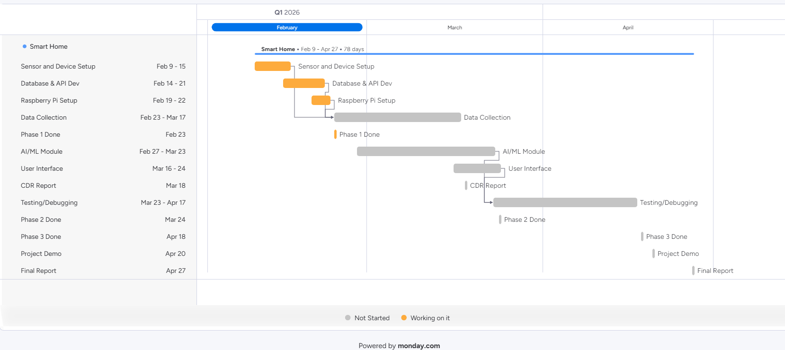
Figure 4: Gantt Chart with Clear Dependencies
To summarize, our first phase will consist of setting up the hardware and database to get ready for data collection. Phase two will consist of setting up the machine learning model and getting it ready to train off the data that will be collected from the environments. During this time, we will also start on our user interface and test API’s to make sure that data is being properly displayed. Phase 3 will consist of the testing and debugging while trying to get everything to work as a whole. With the data being analyzed and users being shown recommendations with reasonings applied to them.
Phase 1 – Core Infrastructure (Feb 9 – Feb 23)
- Sensor and Device Setup (Feb 9 – 15)
- Procure hardware
- Install and wire sensors
- Verify sensor signal output
- Database and API Development (Feb 14 – 21)
- Design schema
- Implement backend endpoints
- Configure cloud connection
- Raspberry Pi Setup (Feb 19 – 22)
- OS configuration
- Sensor interfacing
- API connectivity test

Phase 1 Milestone (Feb 23)
Phase 2 – Data and Intelligence Layer (Feb 23 – Mar 24)
- Data Collection (Feb 23 – Mar 17)
- Logging sensor streams
- Cleaning and formatting data
- Initial dataset validation
- AI/ML Module (Feb 27 – Mar 23)
- Feature extraction
- Model selection
- Training and tuning
- Local integration testing
- User Interface (Mar 16 – 24)
- Dashboard layout
- Alert logic integration
- Backend connection
CDR Report (Mar 18)
Phase 2 Milestone (Mar 24)
Phase 3 – Integration and Delivery (Mar 23 – Apr 27)
- Testing and Debugging (Mar 23 – Apr 17)
- System integration testing
- Performance validation
- Edge case handling
Phase 3 Milestone (Apr 18)
Project Demo (Apr 20)
Presentation preparation
Demo environment setup
Final Report (Apr 27)

5.3 Economic analysis
The Smart Room Monitoring System demonstrates strong economic viability as a potential commercial product within the growing smart home market. While the prototype unit cost is approximately $133 due to low-volume component sourcing and the use of a general-purpose Raspberry Pi, expected production costs would decrease significantly at scale. In a volume-manufactured design, the Raspberry Pi could be replaced with a custom embedded Linux System-on-Chip (SoC), and sensors could be consolidated onto a single printed circuit board, reducing the estimated per-unit cost to approximately $60–$80. This pricing positions the system competitively with existing consumer smart home hubs while offering additional value through integrated AI-driven reasoning across security and energy data. By avoiding mandatory cloud subscriptions and emphasizing local data processing, the system also reduces long-term operating costs for users, increasing its attractiveness in the consumer market.
From a sustainability and manufacturability perspective, the system relies on standardized, commercially available components sourced from multiple vendors, minimizing supply-chain risk and ensuring long-term part availability. Sensor tolerances primarily impact sensitivity rather than functional correctness, allowing calibration and software filtering to compensate for component variation and improve production yield. Manufacturing testability can be achieved through automated validation of sensor outputs, wireless connectivity, and device control functionality. Regulatory compliance requirements, such as FCC certification for wireless communication, are simplified by the use of pre-certified radio modules. Long-term maintenance is largely software-based, including firmware updates and periodic machine learning model retraining, which extends product lifespan and reduces electronic waste. Overall, the system is well-suited for scalable manufacturing and sustainable deployment as a consumer smart home product.

5.4 Societal, safety and environmental analysis
The proposed Smart Room Monitoring System has several societal implications, both beneficial and some things we need to be aware of as we are building our design. From a societal perspective, the system works to improve quality of life of the user by translating raw motion, sound, and energy sensor data into actionable insights through machine learning analysis. Rather than requiring users to interpret the readings of each device individually, the system provides intelligent recommendations with reasoning from the machine learning model. This will allow for the user to enhance their home safety and energy awareness. By tracking patterns and anomalies within the home, the system reduces the burden of constant monitoring while promoting proactive decision-making related to both energy efficiency and home security.
However, the integration of artificial intelligence introduces some ethical considerations we need to be aware of. Machine learning models analyze sensitive homeowner and behavioral data derived from motion and sound sensors, which raises concerns related to the homeowners privacy. In addition to this, centralized storage of this data, if mishandled, could expose sensitive information about the households activity patterns. Users may also over-rely on AI-generated recommendations without full understanding of the limitation of the model. To address these concerns, user data access must be restricted through authenticated methods. The AI outputs must also be designed to provide reasonable, explainable recommendations rather than generic automated decisions.
There are also some safety risks that are associated with the use of smart plugs and wireless sensors in household areas. Electrical safety must be considered when integrating energy-monitoring devices into home outlets. Cybersecurity risks also exist if the system is improperly configured or handled. This could potentially allow for unauthorized access to the device controls or the stored data. Continuing this idea, incorrect AI/ML predictions could also result in false alerts or missed abnormalities. Physical safety risks related to installation are minimal due to the use of low-power, wireless, commercially available devices that do not require invasive wiring.
The environmental impact of the system is primarily positive in nature. The design relies on low-power readily available components to minimize additional energy expenditure. Through machine learning based trend and prediction analysis, the system identifies inefficient energy usage patterns and abnormal energy consumption. This helps to call out and identify behaviors that may not be obvious from raw readings. By notifying users of unused or inefficient devices, the system will aim to reduce any idle energy consumption and overall household energy waste. This will result in a net reduction in energy consumption over time.
To mitigate ethical, safety, and environmental risks, several strategies will be incorporated into the design. Sensor data is to be stored and processed locally whenever possible to reduce exposure to external systems. Secure authorization methods will also be used to restrict access to authorized users only. This will minimize cybersecurity vulnerabilities. AI/ML reasoning is used as a decision tool rather than fully autonomous control, ensuring that users retain final authority over actions taken within their home. Finally, the system offsets its own computational energy usage by actively applying AI-driven analysis to reduce household energy waste. This will also support long-term sustainability.

5.5 Itemized budget

Component | Amount | Amount Per Unit | Cost Per Unit | Subtotal
Raspberry Pi 4 Model B (4 GB) | 1 | 1 | $75.00 | $75.00
Sonoff S31 Smart Plug (Energy Monitoring) | 2 | 1 | $10.00 | $20.00
Sound Sensor | 1 | 5 | $6.49 | $6.49
Motion Sensor | 1 | 5 | $9.99 | $9.99
Amazon SD Card | 1 | 2 | $13.50 | $13.50
Raspberry Pi 15W USB-C Power Supply | 1 | 1 | $8.00 | $8.00
Cost for a unit |  |  |  | $132.98

6 References
Here you acknowledge all the documents that you used as references throughout the text. Please use the IEEE reference format
https://ieeeauthorcenter.ieee.org/wp-content/uploads/IEEE-Reference-Guide.pdf
National Resources Defense Council. Home Idle Load Devices Wasting Huge Amounts of Electricity When Not Active in Use. NRDC, https://www.nrdc.org/resources/home-idle-load-devices-wasting-huge-amounts-electricity-when-not-active-use.
“Burglary Statistics.” Alarms.org, https://www.alarms.org/burglary-statistics/.
GlobeNewswire. “Home Automation Market Is Poised to Skyrocket to Reach Staggering Valuation of USD 715.6 Billion by 2032: High Demand for Smart Home Energy Management Devices Says Astute Analytica.” GlobeNewswire, 9 May 2024, https://www.globenewswire.com/news-release/2024/05/09/2878979/0/en/Home-Automation-Market-is-Poised-to-Skyrocket-to-Reach-Staggering-Valuation-of-USD-715-6-Billion-By-2032-High-Demand-for-Smart-Home-Energy-Management-Devices-Says-Astute-Analytica.html.
Federal Bureau of Investigation. “Crime Clock.” Crime in the U.S. 2019, https://ucr.fbi.gov/crime-in-the-u.s/2019/crime-in-the-u.s.-2019/topic-pages/crime-clock.
Delforge, Pierre. “Home Idle Load: Devices Wasting Huge Amounts of Electricity When\ Not in Active Use.” NRDC, 14 July 2015, www.nrdc.org/resources/home-idle-load-devices-wasting-huge-amounts-electricity-when-not-active-use.
Ring. Ring Alarm Pro Security System. Ring, Inc., https://ring.com/products/security-system-alarm-pro.
Network Technologies Inc. E-1W Environment Monitoring System. Network Technologies Inc., https://www.networktechinc.com/environment-monitoring.html.
ecobee. SmartSensor for Room Temperature and Occupancy. ecobee Inc., https://www.ecobee.com/en-us/sensors/smart-temperature-occupancy-sensor/.
Signify. Philips Hue Smart Lighting System. Signify Holding, https://www.philips-hue.com/en-us.
Aqara. Aqara Smart Home Hub and Sensor Ecosystem. Aqara LLC, https://www.aqara.com/us/products/.

7 Appendices

7.1 Product datasheets
Raspberry Pi 4 Model B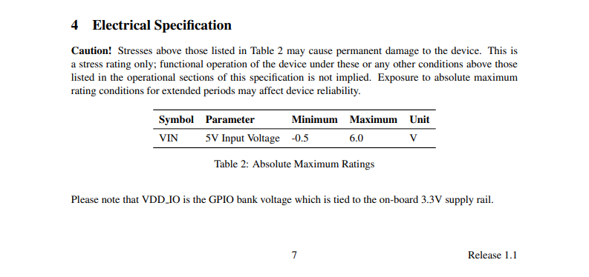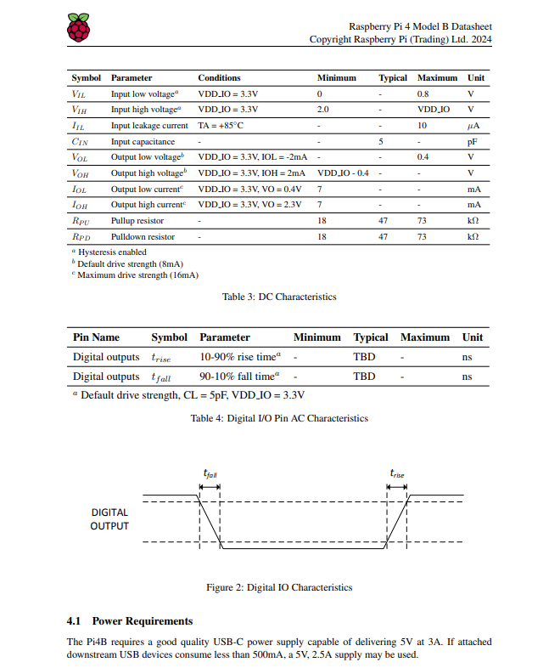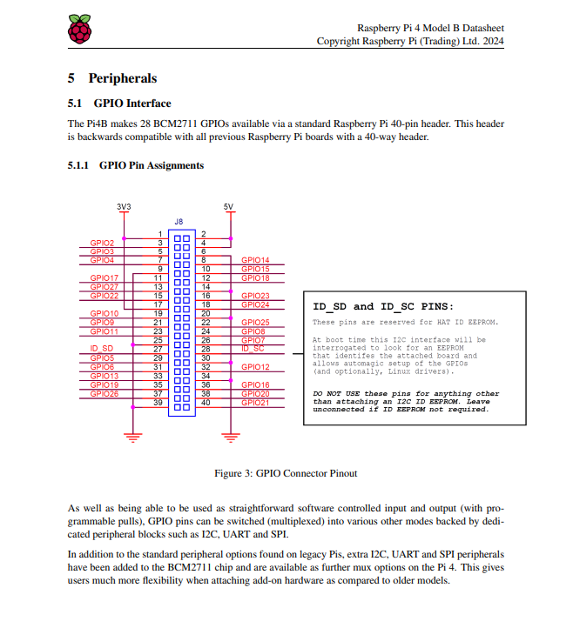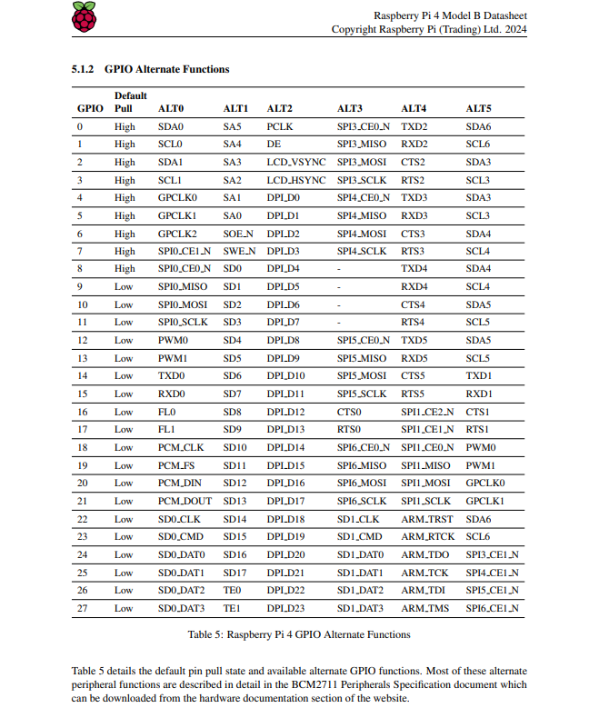

7.2 Bios and CVs
Evan Johnston is a senior computer engineering student at Texas A&M University. He first started out his college career as a part of the Texas A&M Engineering Academy, a dual enrollment program partnered with community colleges. He first started attending Texas A&M full-time in the second semester of sophomore year. He quickly displayed his skills getting offered to work as a Peer Teacher for the Department of Computer Science, a program of successful students who provide assistance to other students within the computer science curriculum. Through this job, he was then offered to work as a Teaching Assistant for an introductory C programming course. He has made it his mission to diversify his skillset taking courses from diverse disciplines such as databases, machine learning, computer graphics and animation, etc.

Shiv K. Ranchhod is a senior Computer Engineering student at Texas A&M University pursuing a minor in Cybersecurity. His academic and professional focus centers on cybersecurity engineering, regulatory compliance frameworks, embedded systems, and hardware-software integration. He most recently served as a Cyber Strategy, Risk, and Compliance Intern at PricewaterhouseCoopers, where he developed structured NIST CSF 2.0 interview frameworks, completed governance scorecards, and contributed to cybersecurity capability modeling initiatives. Previously, he worked as an ETL Developer at Clairvoyance LLC, designing real-time data pipelines using Python and Pandas to enhance data traceability and operational reliability. His technical experience also includes leading the development of a Langflow-based AI regulatory compliance agent and conducting advanced malware analysis involving anti-debugging bypass and network traffic inspection. Shiv is proficient in Python, C/C++, Linux environments, and cybersecurity analysis tools.
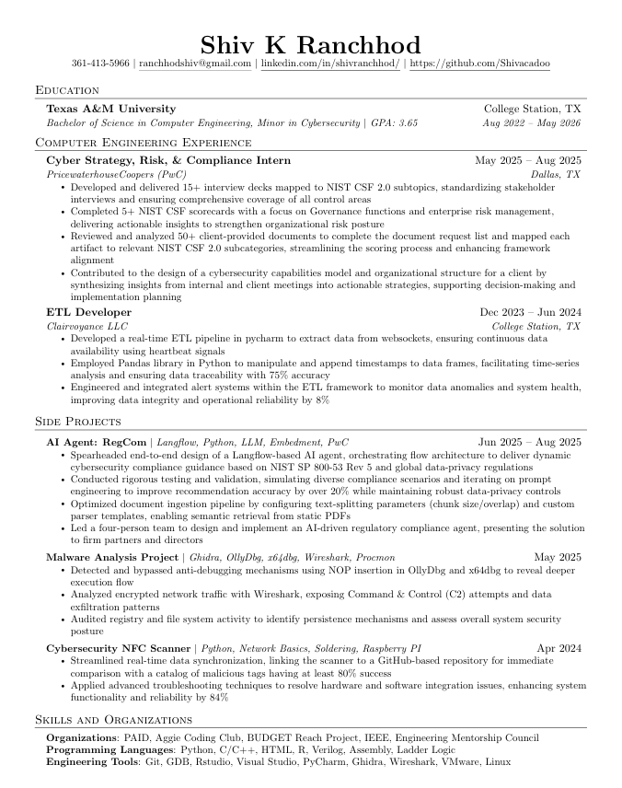
Sutton Elliott is a senior Computer Engineering student at Texas A&M University with a minor in Mathematics. His academic career has seen him develop strong foundational skills in both hardware and software systems. His coursework has spanned throughout machine learning, embedded systems, databases, and software development. Sutton has also earned a Microsoft Azure AI certification, demonstrating an interest in cloud-based artificial intelligence technologies. His technical interests center around bridging the gap between hardware systems and intelligent software models. He is proficient in Python, C/C++, Azure environments, and SQL.

Tyler Rottermond is a senior Computer Engineering student at Texas A&M University with a strong focus on embedded systems, low-level software, and hardware–software integration. He has completed advanced coursework in operating systems, computer architecture, microprocessor systems design, and electric circuit theory, maintaining a 3.95 GPA. His technical experience includes developing embedded software in C/C++ and Python, working in Linux-based environments, designing and analyzing analog and digital hardware systems, and interfacing with custom hardware through device drivers and system-level code. Tyler’s interests center on building reliable, efficient embedded platforms that bridge physical hardware with intelligent software, particularly in applications involving sensing, control, and real-time system behavior.

Sriharsha Jandhyala is a Computer Engineering student at Texas A&M University with experience in software development, data analytics, and applied machine learning. He has built data pipelines and full-stack applications through internships and technical projects, including financial dashboards at CBRE and a restaurant point-of-sale system. He has worked on multiple projects involved in machine learning, including fine-tuning transformer models for text classification using modern optimization techniques. His technical skill set includes Python, C++, SQL, JavaScript frameworks, SDLC tools such as Azure DevOps, and cloud and data tools such as Snowflake and Tableau. Sriharsha is passionate about building data and AI driven software that improves decision-making, efficiency, and overall user experience.


William Xu is a senior Computer Engineering student at Texas A&M University with expertise spanning distributed systems, robotics, and full-stack development. He has completed rigorous coursework in computer architecture, data structures and algorithms, digital system design, and artificial intelligence while gaining hands-on experience across industry and research settings. His technical background includes developing embedded software and hardware simulations in C++, Python, and SystemVerilog, building scalable mobile applications with React Native and cloud infrastructure, and implementing real-time robotics algorithms in ROS2. William's professional experience ranges from architecting distributed neural network systems and high-performance computing pipelines to developing autonomous underwater vehicle software and deploying production mobile applications. His interests lie in building intelligent, scalable systems that integrate hardware and software specifically in robotics, real-time processing, and distributed architectures where performance and reliability are critical.
